AI-Augmented Backend Development Project :

TITLE : FitTrack AI – Personalized Fitness Recommendations Powered by AI

Project Description

In a Single Paragraph
FitTrack AI is an AI-augmented backend web application developed using Node.js, Express.js, MongoDB, and Mongoose, integrated with Google Gemini AI for large-language-model generation, embeddings, semantic search, vector search, and intelligent fitness recommendations. The system enables users to authenticate securely, upload and analyze documents, search content semantically, ask questions through a RAG chat assistant, generate fitness content, receive AI-powered insights, and manage personal workout records through REST APIs. By combining reliable backend engineering with prompt engineering and retrieval-augmented generation, the platform delivers a secure, scalable, and intelligent fitness experience.

Scenario

Paragraph 1 – Problem
Fitness users record workouts in notebooks, spreadsheets, and disconnected applications. This process is time-consuming, prone to missing or incorrect entries, and makes it difficult to search previous workouts or understand progress over time. Traditional fitness applications may store data but do not provide meaningful answers about a user’s documents, do not generate guidance tailored to age, goal, and experience, and do not provide a secure, user-scoped way to manage personal records. Users therefore struggle to turn raw workout data into useful decisions.

Paragraph 2 – AI Solution
FitTrack AI combines secure REST APIs with Google Gemini AI. Users can upload text, Markdown, CSV, or JSON documents. The backend chunks the documents, generates Gemini embeddings, stores vectors in MongoDB, and retrieves relevant chunks through Atlas Vector Search or a local cosine fallback. The RAG chat assistant answers questions using the retrieved context. The system also provides keyword and Atlas Search, document analysis, text summarization, fitness content generation, workout recommendations, and fitness insights. JWT authentication, role-based access, input validation, and user-level data scoping protect every operation.

Paragraph 3 – Impact
Students, working professionals, beginners, and fitness enthusiasts benefit from one secure history, faster document and workout search, and practical AI guidance. Trainers and analysts can use administrator APIs to review activity and AI usage. The RAG assistant reduces the time required to locate and understand fitness information, while recommendations and insights help users make more informed workout decisions. The modular design also allows future PDF parsing, richer chat interfaces, dashboards, and analytics features without redesigning the core backend.

System Requirements :
To ensure smooth development, deployment, and usage of the FitTrack AI AI-Augmented Backend Application, the following system prerequisites must be met.

1. Software Requirements

Operating System
● Windows 10/11
● macOS
● Linux

Node.js (v18 or above)
Provides the runtime environment; the project was verified on Node.js v22.

npm (v9 or above)
Package manager used for dependency installation.

Express.js
REST API framework used for backend development.

MongoDB Community Server / MongoDB Atlas
FitTrack AI uses MongoDB Atlas with Mongoose ODM.
● Users and roles
● Workouts
● Documents and document metadata
● Embeddings
● Chats
● Activity logs

MongoDB Atlas Search
Implemented with the $search stage and a keyword fallback.

MongoDB Atlas Vector Search
Implemented with the $vectorSearch stage and a local cosine fallback.

AI Service Provider
Google Gemini API through the @google/genai SDK.

Embedding Model
gemini-embedding-001 by default.

File Upload
multer memory upload for supported text-based documents.

Authentication
JWT authentication with bcrypt.js password hashing.

API Testing
Postman, Thunder Client, and repeatable end-to-end tests.

Code Editor
Visual Studio Code or equivalent.

Version Control
Git/GitHub recommended.

Custom ML Training
Not used; hosted Gemini models are used.

LangChain/OpenAI SDK
Not used.

2. Hardware Requirements

Processor
Intel Core i5 8th Gen or later / AMD Ryzen 5 or equivalent

RAM
8 GB minimum; 16 GB recommended

Storage
1 GB free space for Node.js and project files

Internet Connection
Required for MongoDB Atlas and Google Gemini

Display
1366 × 768 or above

Project Architecture

Technical Architecture :
The architecture is a modular Node.js and Express.js backend connecting client applications to MongoDB Atlas and Google Gemini. It separates authentication, controllers, AI services, retrieval services, models, and persistence.

Architecture Diagram
Fitness User / Web / Mobile / Postman
|
| JSON or multipart request
v
+--------------------------------------------------+
| Node.js + Express.js Backend |
|--------------------------------------------------|
| Environment Configuration (dotenv) |
| REST Routes: Auth / Workouts / AI / Documents |
| / Admin |
| JWT + Role Middleware |
| Controllers: Auth / Workout / AI / Document |
| / Admin |
| Gemini Service: LLM + Embeddings |
| Retrieval: Atlas Search / Vector Search |
| / Local Fallbacks |
| Mongoose Models |
+--------------------------------------------------+
| | |
v v v
MongoDB Atlas Google Gemini API Retrieval Services
Users/Workouts Text/Embeddings Atlas + Fallbacks
Documents/Chats
Embeddings/Logs

Backend Layer
● Node.js runtime and Express.js REST API
● JWT authentication middleware
● User and admin role middleware
● Controllers for authentication, workouts, AI, documents, and administration
● Centralized JSON error handling

Database Layer
● MongoDB Atlas
● Mongoose ODM
● Users and Workouts collections
● Documents, Embeddings, Chats, and ActivityLogs collections
● Atlas Search and Atlas Vector Search with local fallbacks

AI Layer
● Gemini large language model for recommendations, insights, chat, summaries, content generation, and document analysis
● Gemini embedding model for document vectors
● Prompt engineering and RAG pipeline
● No custom-trained machine-learning model

Storage Layer
● MongoDB collections for persistent application data
● Text documents stored in MongoDB with metadata
● Multer memory upload; no permanent local file storage is required

Security Layer
● JWT Bearer authentication
● bcrypt.js password hashing
● Protected routes
● Input validation
● User and admin role-based access control
● User-scoped document, embedding, chat, and workout queries

ER Diagram

Collections

Users
● _id
● name
● email (unique)
● password
● role
● createdAt
● updatedAt

Workouts
● _id
● user (FK)
● workoutName
● category
● duration
● caloriesBurned
● workoutDate
● createdAt
● updatedAt

Documents
● _id
● title
● content
● originalName
● mimeType
● uploadedBy (FK)
● embeddingStatus
● createdAt
● updatedAt

Embeddings
● _id
● document (FK)
● user (FK)
● chunkIndex
● text
● vector
● model
● createdAt

Chats
● _id
● user (FK)
● message
● response
● mode
● createdAt

ActivityLogs
● _id
● user (FK)
● action
● resourceType
● resourceId
● createdAt

ER Diagram Explanation
A User owns Workouts, uploads Documents, creates Chats, and generates ActivityLogs. Each Document produces multiple Embeddings so that long content can be split into searchable chunks. The RAG chat uses those embeddings to retrieve relevant context before calling Gemini. Admin users can view system-wide users, documents, and activity, while normal users are restricted to their own records.

Features

Core Backend Features
● User registration
● User login and JWT authentication
● Logout endpoint
● Protected routes and role middleware
● User profile
● Workout CRUD APIs
● Keyword/date workout search
● Text document upload and document management
● Chat history
● Activity logs
● User/admin roles
● Centralized error handling
● Postman collection and repeatable end-to-end tests

AI Features
● AI workout recommendation
● AI fitness insights
● Prompt engineering
● Gemini document embeddings
● Semantic search
● Atlas Vector Search with local fallback
● Atlas Search with keyword fallback
● RAG chat assistant
● Document question answering
● Document analysis
● Text summarization
● Fitness content generation
● Natural-language queries

Roles and Responsibilities

Administrator
● View all users
● Promote or demote user roles
● View all uploaded documents
● Review activity logs
● View AI usage summaries
● Manage system-level information through protected APIs

Authenticated User
● Register and log in
● Upload supported documents
● Search documents semantically or by keyword
● Ask questions through RAG chat
● Generate summaries and fitness content
● Add, view, update, and delete workouts
● Request AI workout recommendations and fitness insights
● View and delete personal chat history
To create the first administrator, set ADMIN_EMAIL in .env before registering the administrator account.

User Flow
● 1. User registers and logs in.
● 2. User receives a JWT token.
● 3. User uploads a supported text document.
● 4. The backend stores the document, splits it into chunks, and generates embeddings.
● 5. User performs keyword, Atlas Search, or semantic search.
● 6. User submits a natural-language question.
● 7. The retrieval service finds relevant document chunks.
● 8. Gemini generates a context-aware RAG answer.
● 9. The answer, sources, and activity are stored.
● 10. User reviews workout recommendations, insights, and history.
● 11. Administrators review users, documents, and activity through admin APIs.

MVC Pattern
The backend follows the Model-View-Controller (MVC) pattern, with reusable services for Gemini AI and retrieval operations.

Model Layer
● src/models/User.js — user profile, role, unique email, timestamps, and password hashing
● src/models/Workout.js — workout schema, category enum, validation, user reference, and timestamps
● src/models/Document.js — uploaded document content and metadata
● src/models/Embedding.js — document chunks and vector data
● src/models/Chat.js — chat history and retrieval sources
● src/models/ActivityLog.js — user and AI activity records

Controller Layer
● authController.js — registration, login, profile, role assignment, and logout
● workoutController.js — workout CRUD, search, and ownership checks
● aiController.js — recommendations, insights, RAG chat, semantic search, summary, and content generation
● documentController.js — upload, list, search, analyze, and delete documents
● adminController.js — admin users, roles, documents, activity, and summary

View Layer (Routes)
● /api/auth — register, login, logout, profile
● /api/workouts — CRUD and search
● /api/ai — recommendation, insights, chat, semantic search, summary, content generation, chat history
● /api/documents — upload, list, search, analyze, delete
● /api/admin — users, roles, documents, activity, summary

Advantages of MVC
● Separation of concerns
● Better maintainability
● Reusable AI and retrieval services
● Clear API contracts
● Easier testing
● Room for future fitness modules

Project Setup and Configuration

Project Structure
Code Files/
├── src/
│ ├── config/db.js
│ ├── controllers/
│ ├── middleware/
│ ├── models/
│ ├── routes/
│ ├── services/
│ ├── app.js
│ └── server.js
├── .env
├── .env.example
├── FitTrack.postman_collection.json
├── package.json
└── README.md
The current project uses src as the source folder, with separate controllers, middleware, models, routes, services, and configuration modules.

Server Setup
cd "C:\Users\Latha P\Downloads\Code Files-20260924T055404Z-1-001\Code Files"
npm install

Environment Variables
Create .env in the project root:
PORT=5000
MONGO_URI=your_mongodb_atlas_uri
JWT_SECRET=your_jwt_secret
GEMINI_API_KEY=your_gemini_api_key
GEMINI_MODEL=gemini-3.5-flash-lite
GEMINI_EMBEDDING_MODEL=gemini-embedding-001
ADMIN_EMAIL=admin@example.com
MONGO_VECTOR_INDEX=document_vector_index
MONGO_SEARCH_INDEX=document_search_index
UPLOAD_MAX_BYTES=2097152

Run Backend
npm start
Development mode:
npm run dev
Backend URL:
http://localhost:5000

Backend Development and AI APIs

Authentication APIs
● Registration uses POST /api/auth/register.
● Login uses POST /api/auth/login and returns a JWT.
● Profile uses GET /api/auth/profile and requires a Bearer token.
● Logout uses POST /api/auth/logout; the client discards its JWT.

AI API Consumed
● Provider: Google Gemini API
● SDK: @google/genai
● LLM model: GEMINI_MODEL, default gemini-3.5-flash-lite
● Embedding model: GEMINI_EMBEDDING_MODEL, default gemini-embedding-001

Workout Recommendation
● Purpose: Generate a personalized workout plan.
● Request: { "age": 30, "fitnessGoal": "general fitness", "experience": "beginner" }
● Response: { "recommendation": "..." }
● Cost: Free Tier limits apply; use short prompts and monitor quota.
● Security: JWT required, input validated, API key kept in .env.

Fitness Insights
● Purpose: Analyze workout statistics.
● Request: { "totalWorkouts": 10, "averageDuration": 35, "totalCaloriesBurned": 2500 }
● Response: { "insight": "..." }
● Cost: Keep prompts small and avoid duplicate requests.
● Security: JWT required and API responses must not expose secrets.

Document Embeddings
● Purpose: Convert document chunks into vectors.
● Model: gemini-embedding-001
● Request: Text chunk content
● Response: Numeric vector values
● Storage: embeddings.vector
● Cost: Free Tier usage and rate limits apply.
● Security: Process only authorized user documents and never expose the API key.

RAG Chat
● Purpose: Answer questions using retrieved document context.
● Request: { "message": "How often should I walk?" }
● Response: { "answer": "...", "mode": "rag", "sources": [...] }
● Retrieval: Atlas Vector Search, then local cosine fallback.
● Security: Only the authenticated user’s documents are searched.

Summarization and Content Generation
● Summarize: POST /api/ai/summarize with { "text": "..." }
● Generate content: POST /api/ai/content-generator with { "topic": "...", "contentType": "...", "tone": "..." }
● Both require JWT authentication and validated input.
● Prompts should be concise to control Free Tier usage.

Database Development

Collections
● Users — accounts, roles, hashed passwords, and profile data
● Workouts — user-owned workout records
● Documents — uploaded document content and metadata
● Embeddings — document chunks and vector data
● Chats — user questions, answers, and retrieval sources
● ActivityLogs — user and AI operations

Indexes and Search
● users.email is unique.
● workouts.user supports user-scoped queries.
● documents.uploadedBy supports user-scoped document access.
● embeddings.user supports retrieval isolation.
● Native Atlas Search index: document_search_index on documents.title and documents.content.
● Native Vector Search index: document_vector_index on embeddings.vector, cosine metric, 3072 dimensions.
● Keyword and cosine fallbacks are used when Atlas indexes are unavailable.

Project Execution

Step 1: Backend
npm install

Step 2: Configure Environment Variables
Add the environment variables shown above. Never commit .env.

Step 3: Run Backend
npm start

Step 4: Verify APIs
Use the included Postman collection or the following routes:
GET /
POST /api/auth/register
POST /api/auth/login
GET /api/auth/profile
POST /api/documents
GET /api/documents
GET /api/documents/search?q=cardio
POST /api/ai/semantic-search
POST /api/ai/chat
POST /api/ai/summarize
POST /api/ai/content-ge
Add your recorded demo URL here.nerator
GET /api/admin/summary

Output Screenshots with Explanation
● Server startup — MongoDB connection and listening port
● Authentication — Register, login, JWT, profile, and logout
● Document upload — Multipart upload and embedding status
● Search — Keyword, Atlas Search/fallback, and semantic results
● RAG chat — Retrieved sources and generated answer
● Recommendations — Workout recommendation and fitness insight responses
● Admin APIs — Role protection and admin summary
● Error handling — 400, 401, 403, and 404 JSON responses
● Testing — Passing end-to-end test summary

Demo Video Link

Source Code Drive Link
Add your GitHub or Drive link here.

Mandatory Functionalities
● MVC architecture — Implemented
● JWT authentication — Implemented
● Semantic search — Implemented with Gemini embeddings and vector retrieval
● MongoDB Atlas Search — Implemented with an index and keyword fallback
● MongoDB Atlas Vector Search — Implemented with an index and local cosine fallback
● Prompt engineering — Implemented
● AI API integration — Implemented using Google Gemini
● Role-based access control — Implemented with user and admin roles
● Document upload — Implemented for text-based documents
● RAG pipeline — Implemented for authorized documents

Conclusion
FitTrack AI is now an AI-augmented backend with secure authentication, workout management, document ingestion, Gemini embeddings, semantic and vector retrieval, Atlas Search, RAG chat, document analysis, summarization, content generation, chat history, activity logging, and role-based administration. Native Atlas indexes are documented for production use, while local fallbacks keep the application functional during development.

Selected Project Code (FitTrack AI)
These excerpts are taken from the current project source. No credentials or .env values are included.

1. Server Entry Point
require('dotenv').config();
const app = require('./app');
const connectDB = require('./config/db');
// Establish database connection
connectDB();
const PORT = process.env.PORT || 5000;
// Start server
const server = app.listen(PORT, () => {
console.log(`Server running in development mode on port ${PORT}`);
});
// Handle unhandled promise rejections gracefully
process.on('unhandledRejection', (err, promise) => {
console.error(`Unhandled Rejection Error: ${err.message}`);
// Close server and exit process
server.close(() => process.exit(1));
});

2. Database Connection
const mongoose = require('mongoose');
const connectDB = async () => {
try {
const conn = await mongoose.connect(process.env.MONGO_URI);
console.log(`MongoDB Connected: ${conn.connection.host}`);
} catch (error) {
console.error(`Error connecting to MongoDB: ${error.message}`);
process.exit(1);
}
};
module.exports = connectDB;

3. User Role Schema Excerpt
const mongoose = require('mongoose');
const bcrypt = require('bcryptjs');
const userSchema = new mongoose.Schema(
{
name: {
type: String,
required: [true, 'Please add a name'],
trim: true,
},
email: {
type: String,
required: [true, 'Please add an email'],
unique: true,
trim: true,
lowercase: true,
match: [
/^\w+([\.-]?\w+)*@\w+([\.-]?\w+)*(\.\w{2,3})+$/,
'Please add a valid email address',
],
},
password: {
type: String,
required: [true, 'Please add a password'],
minlength: [6, 'Password must be at least 6 characters'],
},
role: {
type: String,
enum: ['user', 'admin'],
default: 'user',
},
},
{ timestamps: true }
);
userSchema.pre('save', async function (next) {
if (!this.isModified('password')) return next();
const salt = await bcrypt.genSalt(10);

4. Gemini Embedding Excerpt
const generateEmbedding = async (text, taskType) => {
if (!String(text || '').trim()) throw new Error('Cannot create an embedding for empty text');
const config = {};
if (embeddingModel === 'gemini-embedding-001' && taskType) config.taskType = taskType;
const response = await ai.models.embedContent({
model: embeddingModel,
contents: String(text),
...(Object.keys(config).length ? { config } : {}),
});
const values = response?.embeddings?.[0]?.values || response?.embedding?.values;
if (!Array.isArray(values) || values.length === 0) throw new Error('Gemini returned an empty embedding');
return values;
};

5. Semantic and Vector Search Excerpt
const semanticSearch = async (query, userId, limit = 6) => {
const queryVector = await generateEmbedding(query, 'RETRIEVAL_QUERY');
const index = process.env.MONGO_VECTOR_INDEX || 'document_vector_index';
try {
const results = await Embedding.aggregate([
{ $vectorSearch: { index, path: 'vector', queryVector, numCandidates: 100, limit, filter: { user: objectId(userId) } } },
{ $addFields: { score: { $meta: 'vectorSearchScore' } } },
{ $lookup: { from: 'documents', localField: 'document', foreignField: '_id', as: 'document' } },
{ $unwind: '$document' },
{ $project: { documentId: '$document._id', title: '$document.title', originalName: '$document.originalName', chunkIndex: 1, text: 1, score: 1 } },
]);
if (results.length) return { mode: 'atlas-vector-search', results };
} catch (error) {
console.warn('Atlas Vector Search unavailable; using local fallback:', error.message);
}
return { mode: 'local-cosine-fallback', results: await localVectorSearch(queryVector, userId, limit) };
};

6. Route Registration
const express = require('express');
const authRoutes = require('./authRoutes');
const workoutRoutes = require('./workoutRoutes');
const aiRoutes = require('./aiRoutes');
const documentRoutes = require('./documentRoutes');
const adminRoutes = require('./adminRoutes');
const router = express.Router();
router.use('/auth', authRoutes);
router.use('/workouts', workoutRoutes);
router.use('/ai', aiRoutes);
router.use('/documents', documentRoutes);
router.use('/admin', adminRoutes);
module.exports = router;

7. Testing Evidence
Core API suite: 19 passed, 0 failed. Expanded AI feature suite: 19 passed, 0 failed. Focused RAG suite: 4 passed, 0 failed. Temporary test data was cleaned up.

Architecture and ER Diagrams
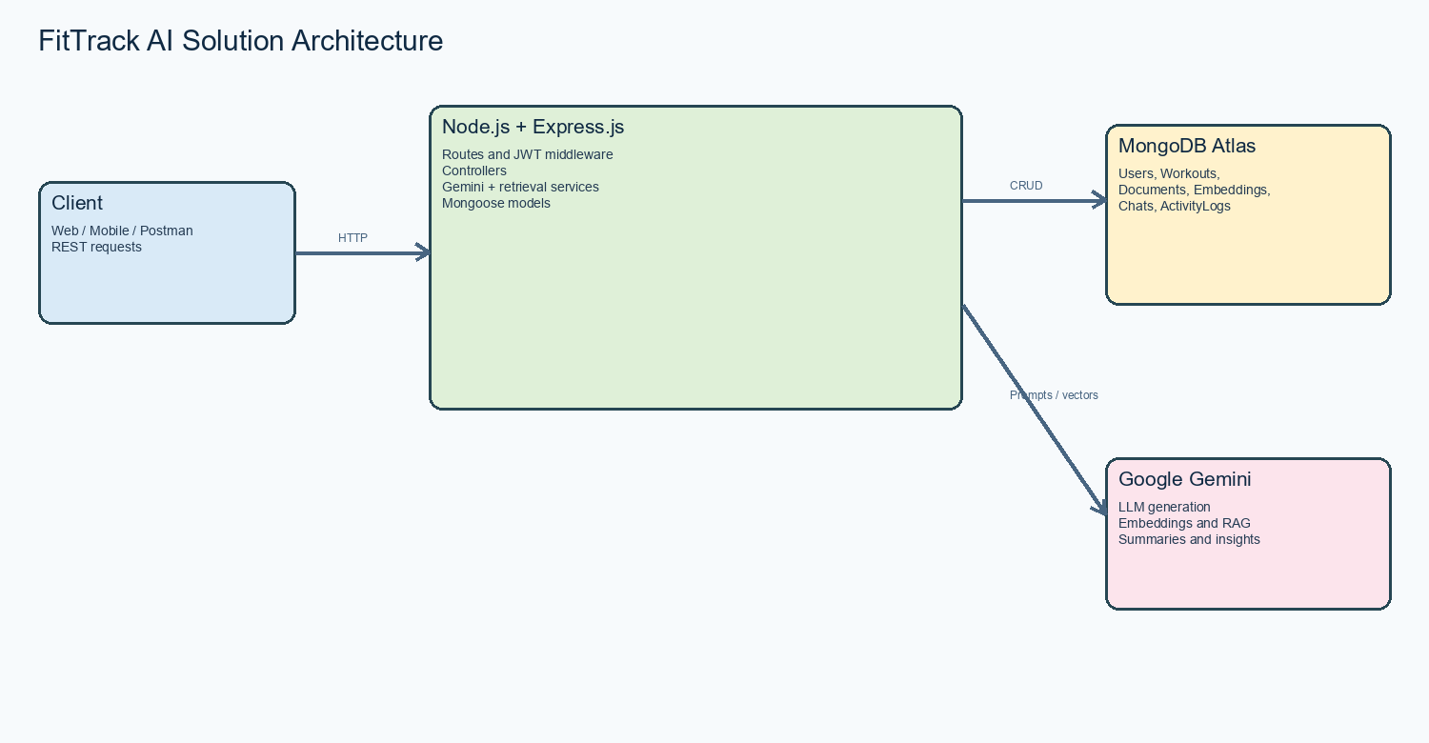
Figure 1: FitTrack AI solution architecture.
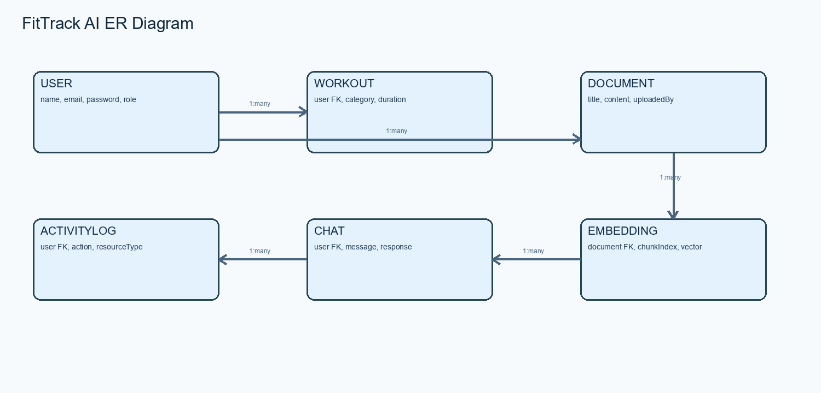
Figure 2: User, workout, document, embedding, chat, and activity relationships.

